

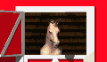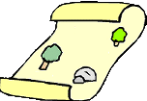

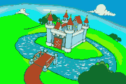

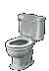

There was a picnic area among the houses.

But now there is a road between the castle and the toilets.

There was a bookshop behind the picnic area.

But now there is a ticket office next to the stables.

